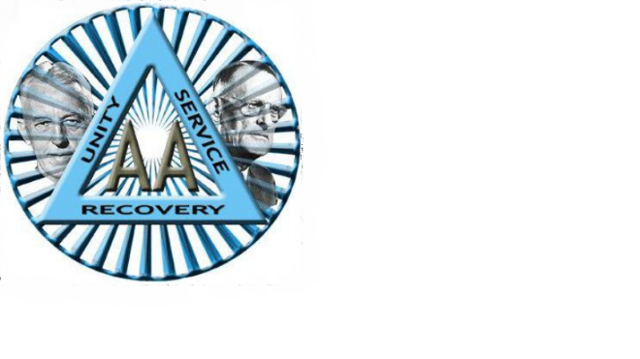
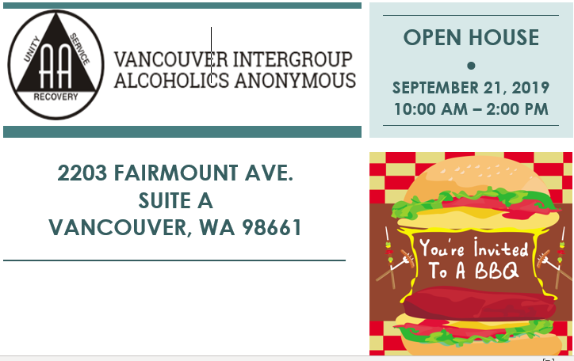

Join us in an open house celebration at Vancouver Intergroup of Alcoholics Anonymous on September 21, 2019, at 10:00 am to 2:00 pm. We welcome you to stop by and enjoy in fellowship eating BBQ and browsing through the bookstore that offers, pamphlets, chips, Big Books, and much more!

Food will be free with a suggested donation of $2.00 per meal, thank you!

The Vancouver Area Intergroup
Phone: 360-694-3870
Email: vancaa@vanintgrp.com
Website: www.vancouveraa.org

