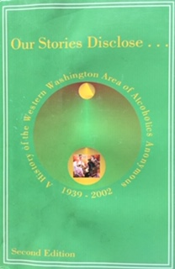
Our Stories Disclose Workshop
Saturday, July 20, 2019
10:00 AM to 2:00 PM
Hosted by District 24, Area 72
Mountlake Terrace Community Senior Center
23000 Lakeview Dr
Mountlake Terrace, WA 98043
Informational meeting open to all area 72 home groups, districts, inter-groups, and halls who are writing their home group histories for the new 3rd edition book. (interpreters must be requested by July 1)
- Panel will share their experience
- Guests include Don and Mary from area 72 Our Stories Disclose Committee
Pizza will be provided. Please bring a side dish to share.

For more information contact:
Mike B. District 24, Alt DCM. mikebourgette@comcast.net
Rita N. District 24, Alt Archives renolan@comcast.net

