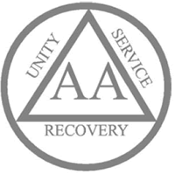

District 7 and 37 Treatment Center Workshop
As part of our primary purpose we carry the message to treatment centers. This workshop is designed to help interested members of the fellowship learn the do’s and don’ts of taking meetings into the greater Vancouver area Treatment Centers.
WHERE: The Lighthouse Bldg A,, 6415 E Mill Plain Blvd, Vancouver, WA 98661
When : Saturday May 18th 7PM to 8:30PM
Cant make it? Email dist37treatment@area72aa.org or
Dist7treatment@area72aa,org and we will email you the info

