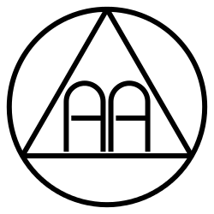

District 37 Corrections Committee
Working with Incarcerated AA Members

Saturday, May 18th 12-2pm
Clark College GHL-Gaiser Hall
2nd Floor, Room 258C
1933 Fort Vancouver Way
Vancouver, WA 98663

Lunch will be provided, followed by guidelines and best practices for working steps with folks in jails and prisons.

